# Proposal Introduction

## Motivation

Many coral reefs around the world are impacted by terrigenous sediment from anthropogenic watershed disturbances like industry, agriculture, deforestation, roads, and urbanization (Burke et al., 2011; Halpern et al., 2008). Land cover change can alter the timing, composition, and mass of sediment loads to coral reefs, causing enhanced sedimentation on corals near the outlets of impacted watersheds (Syvitski et al., 2005). Impacts of these land cover changes are exacerbated on tropical islands characterized by high rainfall, extreme weather events, steep slopes, erodible soils, and naturally dense vegetation, where land clearing alters the fraction of exposed soil much more than in regions with sparse vegetation. Sediment can bond with and transport other pollutants, attenuates light for photosynthesis, prevents larval recruitment, and stresses or smothers the coral organisms (Fabricius, 2005). Deposited sediment can be resuspended due to wave action and reworked over the reef, causing persistent negative effects to ecosystem health (Wolanski et al., 2003) and distributing impacts to larger areas (Presto et al., 2006). Damage to coral organisms and ecosystems is determined by the magnitude and duration of exposure, which are controlled by hydrodynamic processes (Storlazzi et al., 2009). In addition to monitoring coral health, effective coral reef conservation requires a more integrated understanding of sediment dynamics linking sediment discharge from the watershed, hydrodynamics on the reef, and the resulting sedimentation exposure to corals (Downs et al., 2005; Klein et al., 2012; Risk, 2014). Coral reef managers are interested in establishing baselines for objective metrics of intervention success like reduced sediment loading to bays or reduced sedimentation on coral reefs (Kroon, 2012), and these require simple yet effective methods to quantify sediment yield from key areas, characterize current circulation over the reef, and measure sedimentation rates on corals.

## Previous Research and Scientific Motivation

Previous approaches to assess anthropogenic impacts on coral reefs have analyzed coral health over time (Dahl and Lamberts, 1977), or correlated reef health with stream water quality across various sites (Houk et al., 2005). Many researchers continue to use coral health metrics to assess anthropogenic impacts (Houk et al., 2013) but it is difficult to attribute changes in coral health to a specific stressor (Grigg 1995). Biological approaches may document increased sedimentation on corals but fail to address the specific process(es) increasing sedimentation, and hence an opportune point of intervention for environmental managers (Downs et al., 2005). As an alternative to the biological monitoring approaches, groups such as the USGS Ridge-to-Reef Program (see Field et al. (2008), and references therein) have pursued integrated, process-oriented research to provide scientific information on sediment sources and dynamics to resource managers (Atkinson and Medeiros, 2006).

Coral sedimentation field studies like Ridge-to-Reef have three general components, which are reflected in the three chapter structure of this dissertation: watershed inputs, hydrodynamic circulation over the reef, and how they interact to govern spatiotemporal distribution of sedimentation on the reef. Each of the three components requires significant expertise and specialized equipment, so most studies have either focused on only one component, or integrate large-scale collaborative efforts between watershed scientists, oceanographers, and coral ecologists (Draut et al., 2009; Fabricius et al., 2012; Storlazzi et al., 2009). These large-scale collaborative efforts are important for integrating state-of-the-art knowledge in each field, but are generally beyond the capabilities of management-oriented investigations, or focus on large, complex study sites (Fabricius et al., 2012).

There is significant uncertainty in the natural background rate of sediment loading from watersheds to coral reefs, in the magnitude of human impacts on sediment loading for storm events of different sizes, and in the main human activities that impact sediment loading, particularly on small tropical islands with limited data. Approaches for quantifying sediment discharge from steep, tropical watersheds to fringing reef embayments have included sediment budgets (Ramos-Scharrón and Macdonald, 2007; Stock et al., 2010), use of Universal Soil Loss Equation methods (Calhoun and Fletcher, 1999), and in situ measurements (Calhoun and Fletcher, 1999; Wolanski et al., 2005). Evidence from several coastal watersheds in New Zealand shows strong potential for modeling sediment loading from watersheds using the maximum event discharge (Basher et al., 2011; Fahey et al., 2003; Hicks, 1990) but this approach has not been tested in tropical, volcanic islands.

Significant research has been conducted on sedimentation dynamics in coral reefs in Hawaii (Presto et al., 2006; Storlazzi et al., 2009), Great Barrier Reef (Fabricius et al., 2012; Wolanski et al., 2005), Guam (Wolanski et al., 2005), Virgin Islands (Gray et al., 2012), Puerto Rico (Ryan, et al., 2008), Okinawa (West and van Woesik, 2001), Pohnpei (Victor et al., 2006) and New Caledonia (Ouillon et al., 2010). However, few studies have developed an integrated understanding of sediment sources, transport processes, and deposition in small, reef-fringed embayments (Bartley et al., 2014; Draut et al., 2009; Wolanski et al., 2003). Two integrated studies from Hanalei Bay in Kauai, HI, which were part of the ridge-to-reef program of the USGS (Draut et al., 2009; Storlazzi et al., 2009) demonstrated that in addition to total sediment loading and water circulation, the phasing of flood events and wave conditions was a key control on the sediment deposition rate and residence time. As opposed to temperate regions where sediment deposition is limited because river floods and high wave energy are caused by the same frontal system, sediment discharge and wave events can be decoupled in many tropical regions (Draut et al., 2009). In these tropical regions, sediment deposition and residence time is controlled by the variable phasing of sediment discharge during floods, and wave conditions either limiting initial deposition, or resuspending and dispersing previously deposited sediment (Storlazzi et al., 2009; Takesue et al., 2009).

# Research Design

The objective of this dissertation is to document relationships and interactions between sediment discharge from the watershed, wave-driven circulation over the reef, and the spatial distribution of sediment accumulation rates under various conditions in a linked watershed and reef-fringed embayment. This research will be structured around three separate papers that will develop a top-down model of sediment dynamics in Faga’alu, American Samoa, which has been identified as a priority reef for mitigation of sediment-related impacts on coral reefs (Burke et al., 2011).

***Paper One,*** “*Contributions of human activities to suspended sediment yield during storm events from a steep, small, tropical watershed”,* will quantify sediment loading from an undisturbed forest and enhanced sediment loading by human disturbance in Faga’alu and Nu’uuli watersheds during both baseflow and storm events. A combination of paired- and nested-watershed study designs using sediment budget, disturbance ratio, and sediment rating curve methodology will quantify the contribution of human-disturbed areas to total sediment loading to Faga’alu Bay. In situ measurements of precipitation, stream discharge and suspended sediment concentration data collected over three field campaigns (2012-2014) are used to estimate per-storm-event suspended sediment yield from the natural and human-impacted sub watersheds in Faga’alu, and the natural and urbanized subwatersheds in Nu’uuli. An empirical model of event-based suspended sediment yield (SSY) to Faga’alu Bay will be developed to provide the background necessary to assess the effectiveness of future sediment mitigation at the quarry, and as a component of a top-down model of sedimentation on the reef developed in Paper Three. The developed models of SSY are also useful for advancing research efforts towards regional and global prediction of SSY in small mountainous watersheds (Duvert et al., 2012)

***Paper Two,*** “*Eulerian and Lagrangian measurements of flow and residence time on a fringing reef flat embayment”*, will use a combination of Lagrangian (GPS-logging drifters) and Eulerian methods (Acoustic Doppler Current Profilers) deployed over an intensive 2-week field campaign to characterize flow patterns and speeds over the reef, and their relationship to wave, wind, and tidal forcing. Flow patterns and flow speeds are used to develop a model of spatially distributed residence time of water over the reef, based on model output of wave height (WaveWatch III), and routinely collected wind speed, wind direction, and tide height. The developed model of water residence time will be incorporated as a component of a top-down model of sedimentation on the reef developed in Paper Three

***Paper Three, “****Watershed and oceanic controls on seasonal and temporal patterns of sediment deposition in a fringing reef flat embayment”,* will use measurements of monthly terrigenous sediment accumulation on Faga’alu reef to develop a top-down, spatially distributed model of net monthly sediment accumulation based on sediment input and residence time in the Bay. Sediment input from the watershed will be estimated from the model of sediment loading to the Bay developed in Paper One, and residence time will be estimated from the model of residence time over the reef, developed in Paper Two.

## Funding sources for fieldwork

Stream monitoring in Faga’alu and Nu’uuli was funded by two National Oceanic and Atmospheric Agency (NOAA) Territorial Management grants administered by the Coral Reef Advisory Group in American Samoa (CRAG)($45,000 and $63,000), and coral sedimentation monitoring in Faga’alu Bay has been funded by the NOAA Coral Reef Conservation Program (CRCP)($55,000). The US Geological Survey’s (USGS) Coastal and Marine Geology Program (CMGP) Pacific Coral Reef Project supplied $64,000 in oceanographic equipment for the hydrodynamic studies in the bay. The study site, Faga’alu, was selected by the U.S. Coral Reef Task Force (USCRTF) as one of three National Priority Watersheds for ecological/coral restoration efforts. This research is expected to identify and quantify key sources of sediment and nutrient loading to Faga’alu Bay, monitor sediment and nutrient loading from natural and disturbed areas in Nu’uuli to compare to Faga’alu, and monitor sedimentation on the coral reef in Faga’alu Bay. Novel datasets collected in the field will be used to develop and parameterize simple models of land-based coral sedimentation to focus management efforts and develop objective metrics of management effectiveness. The methodology developed is intended for environmental management with few resources in data-scarce, tropical watersheds.

The following section of the dissertation proposal is organized around each of the three papers outlined in the Introduction, with each of the respective methodologies described individually:

# Paper/Part One: “Contributions of human activities to suspended sediment yield during storm events from a steep, small, tropical watershed”

**Intended Journal:** [**Journal of Hydrology**](http://www.journals.elsevier.com/journal-of-hydrology/)**, Impact Factor: 3.654**

## Introduction

Successful reduction of sedimentation threats to coral reefs requires first identifying and quantifying the land-based sources of sediment to focus management efforts in the watershed and design mitigation measures. On Molokai, Stock et al. (2010) found that less than 5% of the land produces most of the sediment, and of that 5%, only 1% produces ~50% of the sediment. In order to reduce sediment stress on reefs, it may be sufficient to mediate the hotspots (Risk, 2014). Previous studies have used mineralogical analyses of fluvial and benthic sediment samples to “fingerprint” sediment to sources (Evrard et al., 2011; Hancock et al., 2006; Takesue et al., 2009) but this approach is less useful where geology is homogenous, and does not yield direct measurements of sediment yield from the watershed or specific sediment yield from key sources. Currently, there is no generic procedure for accurate prediction of suspended sediment yield (SSY) from small, mountainous watersheds (Duvert et al., 2012). Existing sediment yield models are not well-calibrated to the climatic, topographic, and geologic conditions found on steep, tropical islands, making field methods more suitable for estimating SSY from watersheds in those types of environments (Calhoun and Fletcher, 1999). Knowledge on fluvial sediment yield on most Pacific volcanic islands remains limited, in part because of the lack of data and the problems associated with conducting field investigations in remote and isolated islands (Terry et al., 2006). Monitoring SSY from remote streams that are dominated by infrequent, high magnitude storm events is expensive and requires technical skills unavailable to many local managers (Bartley et al., 2012). Developing reliable models that predict SSY from small, mountainous catchments is a significant contribution for local coral conservation, and can also further improve models applied at the regional scale, where societal needs are greatest (Duvert et al., 2012).

The magnitude of both the natural baseline and human-impacted sediment load may change with event size. As event size increases, the magnitude of the natural background water and/or sediment discharge may increase, diminishing the relative anthropogenic impacts, as has been observed for large-magnitude flood events in Mediterranean climates (White and Greer, 2006). Paired watershed studies in Pacific Northwest forests have documented -40 to 300% changes in storm-total SSY from logging and roads (Lewis et al., 2001), but noted that the relative increase in SSY from disturbed lands was higher for small events. While large storms deliver the most total sediment in natural conditions, human-disturbed areas may show the most significant change from natural conditions for smaller storms (Lewis et al., 2001).

Total SSY generated by storm events with similar characteristics can be used to compare the responses of different watersheds (Basher et al., 2011; Duvert et al., 2012; Fahey et al., 2003; Hicks, 1990), assess the contribution of individual subwatersheds to total SSY (Zimmermann et al., 2012), or determine changes in SSY from the same watershed over time (Bonta, 2000). Several studies have found significant correlation between total storm event SSY (SSYEV) and various precipitation and discharge variables, but the best correlation has consistently been with peak event discharge (Qmax). Several researchers have hypothesized that Qmax correlates with SSYEV because Qmax is an integrator of the whole hydrological response of a given watershed to a given storm event. Rankl (2004) argued that the largest variability in event SSYEV is the result of variability in rainstorm energy. Since Qmax depends on the intensity and depth of rainfall, he concluded that a relation should exist between SSYEV and Qmax as both are driven by rainfall energy. Li et al. (2004) proposed the use of a runoff erosivity index instead of traditional rainfall erosivity for the prediction of SSYEV, hypothesizing that discharge characteristics better integrate the watershed response than precipitation variables. Duvert et al. (2012) hypothesized Qmax is a meaningful variable because it relates to both the sediment production on the hillslope and in the channel, as well as the transfer functions of sediment dynamics. They argue that where runoff is produced by infiltration excess overland flow, Qmax is a function of rainfall intensity and the duration of high intensity rainfall (rather than total rainfall), and that where runoff is produced by saturation excess overland flow, Qmax depends on the soil antecedent wetness conditions and by all the sub-surface processes-interflow, translator flow, etc. Duvert et al. (2012) argued that by being responsive to these important hydrological processes, Qmax is a good predictor variable of SSYEV in diverse environments. High correlation between SSYEV and Qmax has been found in semi-arid, temperate, and sub-humid watersheds in Wyoming (Rankl, 2004), Mexico, Italy, France (Duvert et al., 2012), and New Zealand (Basher et al., 2011; Hicks, 1990), but this approach has not been attempted for steep, tropical watersheds on volcanic islands.

## Part One Research Questions

The research questions for this paper are:

1. How has human disturbance altered the sediment loading to Faga’alu Bay?
2. How do sediment contributions from human-disturbed areas and undisturbed areas vary with storm size?
3. Which is the best predictor of event-based suspended sediment yield at each location: total precipitation, Erosivity Index, total discharge, or maximum event discharge?

## Study Sites

The two study watersheds, Faga’alu and Nu’uuli (Figure 1) are characterized by large areas of undisturbed, steeply sloping, heavily forested hillsides in the upper watershed, and relatively small flat area that is urbanized or densely settled in the lower watershed. Initial monitoring efforts focused on Faga’alu, which discharges to a sediment-impacted reef previously identified by local managers (Aeby et al., 2006). Faga’alu includes two unique features not found in “typical” watersheds in American Samoa: 1) an open aggregate quarry, and 2) a large impervious area associated with the island’s only hospital (Figure 2). Nu’uuli watershed is adjacent Faga’alu and is similar in precipitation, size, relief, and landcover, providing an opportunity to compare sediment loading from a more “typical” watershed and estimate the influence of the quarry and impervious area in Faga’alu.

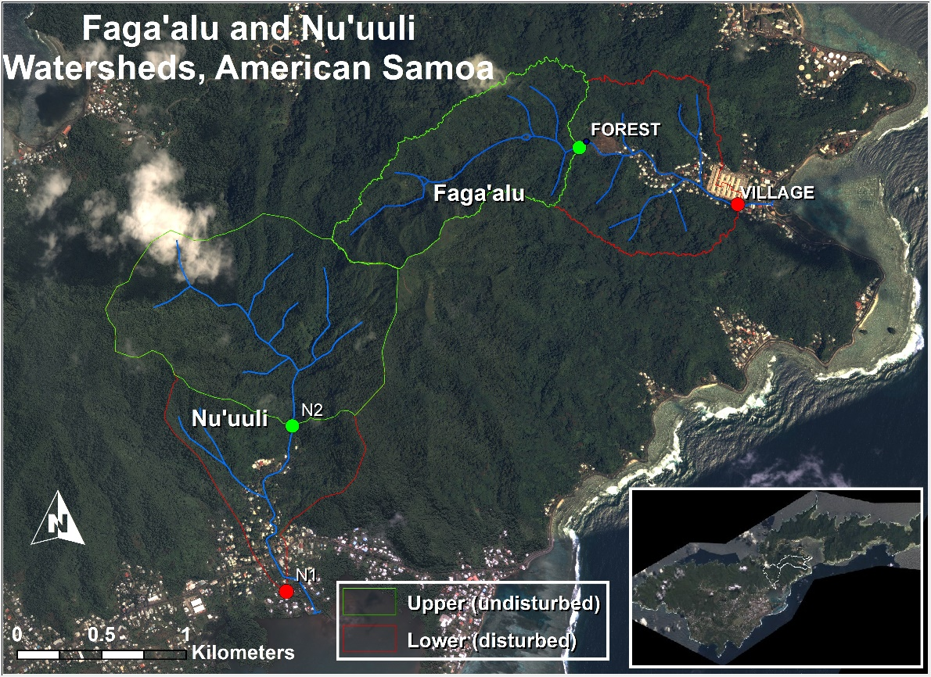

Figure 1 Faga'alu and Nu'uuli watersheds showing upper (undisturbed) and lower (human-disturbed) sections. They drain opposite sides of Matafao Mtn., the highest point on Tutuila (653m). Inset shows locations of barometric pressure stations (Tafuna, Faga’alu, NSTP6, Tula). Instrumentation to monitor continuous suspended sediment yield (SSY) was installed at N1, N2, FOREST, and VILLAGE.

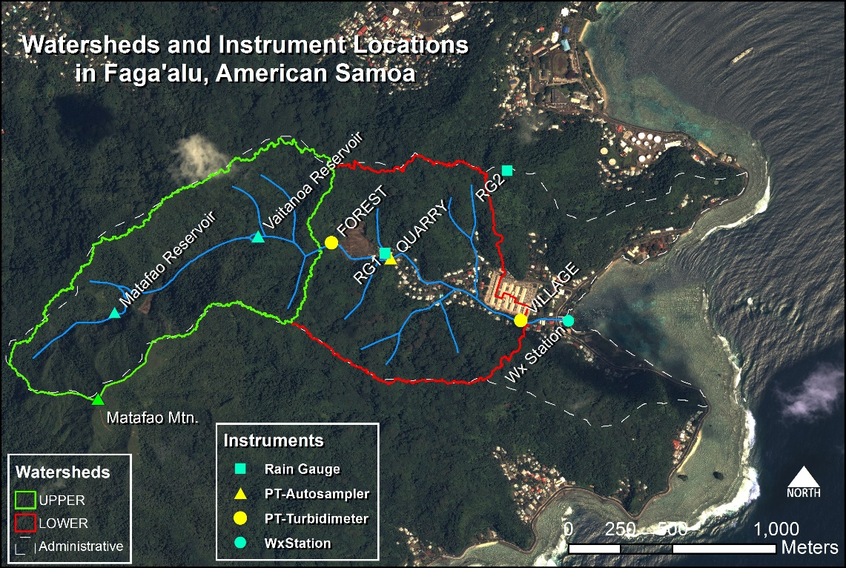

Figure 2 Faga’alu watershed and instrument locations. Grab samples for suspended sediment concentration (SSC) were collected at all three PT locations (FOREST, QUARRY, VILLAGE).

## Methods

A combination of paired- and nested-watershed study designs will quantify the contribution of human-disturbed areas to sediment loading to Faga’alu Bay during baseflow and during events of varying magnitude. The paired watershed approach is used to compare sediment yield from undisturbed and human-disturbed areas in Faga’alu with similar undisturbed and human-disturbed areas in Nu’uuli. The nested watershed approach is used to construct a sediment budget, and to assess the contributions of undisturbed and human-disturbed areas to total sediment loading.

While steep, mountainous streams can discharge a high amount of bedload (Milliman and Syvitski, 1992), this research is focused on sediment size fractions that can be harmful to corals (Bartley et al., 2014). These are the particle sizes that can be transported in suspension in the marine environment to settle on corals and this is generally restricted to silt and clay fractions (<16um) (Asselman, 2000).

The sections below describe the equations used to quantify sediment loading, disturbance ratio, and the sediment budget. Section “Field Data Collection” details the field methods used to collect the data required for the calculations.

### Estimating event suspended sediment yield (SSYEV)

Annual or seasonal total SSY can be used to quantify the spatial and temporal patterns of sediment loading (Fahey et al., 2003), but annual totals can be influenced by climatic variability, leading to uncertain assessments of human impact and management effectiveness for the full range of storm sizes and interannual variability in storm number, size, and sequence. Another approach is to assess changes in the sediment rating curve (Q-SSC relationship) (Walling, 1977). However, it is complicated by hysteresis effects and is difficult to compare between watersheds (Asselman, 2000; Zimmermann et al., 2012). Preliminary data from the study site showed only weak correlation between Q and SSC, with significant hysteresis during storm- and baseflows, so the Q-SSC relationship was not used.

An alternative approach to detecting human impacts on SSY is to compare SSY generated by storm events of the same magnitude. SSY from the same size storm is assumed to be equal, and any difference can be attributed to human disturbance or watershed management. Total SSY from a storm event (SSYEV) is found by integrating continuous suspended sediment load from measured or modeled discharge (Q) and suspended sediment concentration (SSC) (Duvert et al., 2012):

|  |  |  |
| --- | --- | --- |
|  | $${SSY}_{EV}= \int_{0}^{T}{Q*SSC*dt}$$ | Equation 1 |
| where *SSYEV* is suspended sediment yield (tons) from 0=storm start to T=storm end, *SSC* is suspended sediment concentration (mg/L), and *Q* is discharge (L/sec). | | |

Storm events can be defined by precipitation (Hicks, 1990) or discharge parameters (Duvert et al., 2012), and the method used to separate storm events on the hydrograph can significantly influence the analysis of event-based SSY (Gellis, 2013). Complex graphical or rule-based techniques for hydrograph separation may be implemented (Dunne and Leopold, 1978), but for this research the simple stage height threshold rule was used due to the flashy hydrologic response, low baseflow discharge, and short duration of recession curves between events (Fahey et al., 2003; Lewis et al., 2001). A storm event is defined as the period of time where stream stage height exceeds a chosen threshold.

### Sediment budget

A sediment budget quantifies the contribution of key sediment sources to the overall sediment yield (Bartley et al., 2012; Reid and Dunne, 1996; Slaymaker, 2003; Warrick and Mertes, 2009). Both Nu’uuli and Faga’alu watersheds were separated into nested watersheds for analysis, following a similar scheme. The total watershed (TOTAL), draining to VILLAGE in Faga’alu and N1 in Nu’uuli, was separated into two nested subwatersheds: the upstream, undisturbed forest portion of the watershed (UPPER), and the downstream, human-disturbed portion of the watershed (LOWER) (Figure 1). In Faga’alu, an additional subwatershed, draining to QUARRY, was delineated and analyzed to assess the contribution of this key sediment source.

The percent contribution of each subwatershed to SSY from the total watershed is calculated by difference between SSY observed at the upper and lower monitoring stations for each storm event. The disturbance ratio (DR) is the ratio of SSYLOWER under current conditions (=SSYTOTAL - SSYUPPER) to SSYLOWER under pre-disturbance conditions (SSYLOWER.pre) :

|  |  |  |
| --- | --- | --- |
|  |  | Equation 2 |

SSYunder pre-disturbance conditions (SSYLOWER.pre) is calculated assuming that the specific SSY from forested parts of the lower watershed is similar to the specific SSY from the upper watershed:

|  |  |  |
| --- | --- | --- |
|  | $${SSY}_{Lower pre}= {Area}_{TOTAL}* \left(\frac{{SSY}_{UPPER }}{{Area}_{TOTAL}} \right)$$ | Equation 3 |

The percent contribution and DR were calculated for each storm and averaged to determine the average contribution of each subwatershed to total sediment loading.

It is hypothesized that the disturbance ratio is highest for small storms, when background SSY from the undisturbed forest is low and erodible sediment from disturbed surfaces in the lower watershed is the dominant source, but for large storms mass movements and bank erosion contribute to naturally high SSY from the undisturbed upper watershed, reducing the DR for large events.

### Predicting SSYEV

Sediment yield during a storm event (SSYev) may be correlated with precipitation or discharge variables (“storm metrics”). Four predictors used in this research are total event precipitation (Psum), EI30 rainfall erosivity (EI30) (Hicks, 1990), total event discharge (Qsum), and maximum event discharge (Qmax) (Duvert et al., 2012). Predictor variables may be linearly or nonlinearly correlated with SSYEV, so both Pearson’s and Spearman’s correlation coefficients between SSYEV and each of the predictor variables will be calculated from non-transformed data to select the best predictor of event SSY from each subwatershed and from the total watershed.

The relationship between event SSYEV and storm metrics is often best fit by a watershed-specific power law function of the form:

Equation 1 SSY-Qmax Power function

|  |  |  |
| --- | --- | --- |
|  | $${SSY}_{EV }^{}= αX_{m}^{β}$$ | Equation 4 |
| where X is a characteristic of a storm, and the regression coefficients α and β are obtained by ordinary least squares regression on the logarithms of *SSYev* and *Qm* (Basher et al., 2011; Duvert et al., 2012; Hicks, 1990). | | |

Linear functions were fit to untransformed (Linear) and log-transformed dependent and independent variables (Power Law), and coefficients of determination (r2) were calculated to determine best fit.

Equation 4 may also be normalized to watershed area, which facilitates comparison among watersheds of different sizes, including other watersheds studied in existing literature (Duvert et al, 2012).

### Field Data Collection

A combination of continuous measurements of precipitation, turbidity and water stage, and grab samples of water collected during baseflow and storm events were used to calculate SSYEV and storm characteristics at five sampling locations (FOREST, QUARRY, VILLAGE, N1, and N2). Data were collected over three main field campaigns and several periods of unattended monitoring from January, 2012, to March, 2014. In situ instrument data is currently being downloaded monthly, and another field campaign is planned for October 2014 to January 2015. Field campaigns coincided with the wet season and high storm probability. Three field campaigns were conducted: January-March 2012, February-July 2013, and January-March 2014. More detailed description of data collection and methods can be found in the Appendix and the companion document “Quality Assurance Project Plan: Physical Monitoring of Surface Waters in American Samoa.” In brief, rain gauges were installed at three locations in Faga’alu and at two locations in Nu’uuli; pressure transducers were installed at upstream and downstream locations in Faga’alu (FOREST, VILLAGE) and Nu’uuli (N1 and N2), and rating curves relating stage to discharge were calculated from a combination of field data collection and hydraulic models. Grab samples for SSC were collected for a total of xx storms in Faga’alu and xx storms in Nu’uuli, with a goal of sampling xx more storms at in each watershed during Fall 2014.

Turbidimeters (Greenspan TS3000, YSI 600OMS, and CampbellSci OBS500) were installed at four locations (FOREST, VILLAGE, N1 and N2). Continuous SSC is calculated from 15 min interval turbidity data (T) and a T-SSC relationship calibrated with SSC grab samples over a range of turbidity values (Gippel, 1995; Lewis, 1996). If turbidity data are unavailable but sufficient stream water samples are collected during a given storm (n>3?), SSY is calculated directly using event mean concentration of SSC samples (Harmel et al., 2006b; Lewis et al., 2001). Due to logistical and financial constraints, continuous event-based SSY using turbidimeters could only be measured upstream (FOREST, N2) and downstream of the villages (VILLAGE, N1). To sample SSY from the quarry, a key sediment source in Faga’alu, an ISCO 3700 Autosampler was installed (QUARRY, Figure 2) to collect stream water samples at 30 min intervals during storm events. SSYEV at QUARRY was calculated from event mean concentration (EMC) (Bartley et al., 2012) and the specific discharge from forested areas using discharge data from FOREST, and bare soil using the SCS Curve Number approach (Garen and Moore, 2005).

### Uncertainty

Uncertainty in sediment yield calculated from Equation 1 with input data from turbidity meters and streamflow measurements arises from both measurement and model errors (Harmel et al., 2006a). Harmel et al. (2006a) provides a lookup table for measurement uncertainty for standard field methods for stream discharge measurement with a flowmeter and grab samples analyzed gravimetrically for SSC. Here I assume that field methods are appropriately chosen and implemented, so the additional model errors in estimation of SSY are related to uncertainty in estimates of Q and SSC, which are calculated using stage-discharge rating curves (Q) and the T-SSC relationship (SSC) (Harmel et al., 2009).

Methods for estimating uncertainty in the final SSY estimate include Monte Carlo methods (Navratil et al., 2011; Zimmermann et al., 2012), uncertainty extremes (Warrick and Mertes, 2009), and the Root Mean Square Error (RMSE) method (Topping, 1972); but the RMSE method was chosen due to its simplicity and acceptance in hydrologic studies (Harmel et al., 2009). The RMSE method estimates the ‘‘most probable value’’ of the cumulative or combined error by propagating the error from each procedure (Stage-Q, T-SSC) (Topping, 1972). The resulting cumulative probable error (uncertainty) is the square root of the sum of the squares of the maximum values of the separate errors:

|  |  |  |
| --- | --- | --- |
|  | $$PE= \sqrt{\sum{{(E}_{Qmeas}^{2}+E_{SSCmeas}^{2})+{(E}_{Qmod}^{2}+E_{SSCmod}^{2})}}$$ | Equation 5 |
| where PE is the cumulative probable error for individual measured values (±%), EQmeas = uncertainty in individual discharge measurements (±%), ESSCmeas = uncertainty in suspended sediment concentration measurements (± %), EQmod = uncertainty in discharge modeled by the Stage-Q relationship (±%), ESSCmod = uncertainty in suspended sediment concentration modeld by the T-SSC relationship (± %), (Harmel et al., 2009). | | |

PE will be calculated for each storm event to add statistical measures of uncertainty to estimates of SSYEV. The effect of uncertain values of SSY on the hypotheses tested about sediment yield and SSY-Qmax relationships will be tested by visual inspection. If the uncertainty estimates and confidence values significantly overlap, it will be difficult to make conclusions about differences in SSY from the subwatersheds, given the high amount of uncertainty in the measurements. This is common in sediment yield studies where successful models estimate SSY with ±50-100% accuracy (Duvert et al., 2012), but it is believed that the difference in SSY from the upper and lower watershed will be significantly larger than the uncertainty in the measurements.

## Expected Results/Outcomes

It is hypothesized that human land use in Faga’alu, mainly by open-pit aggregate mining, has significantly increased terrigenous sediment loading to the bay above the undisturbed baseline. This will be tested by 1) comparing Q-SSC relationships measured below the undisturbed and disturbed watersheds, 2) average Disturbance Ratio and percent contribution to total sediment load, and 3) comparing event-based SSY rating curves from the undisturbed and disturbed watersheds. These analyses will provide novel data on SSY under natural and disturbed conditions from small, mountainous watersheds on volcanic, Pacific Islands.

The resulting empirical model of event-based suspended sediment yield to Faga’alu Bay will be used by NOAA’s Coral Reef Conservation Program (CRCP) to assess the effectiveness of future sediment mitigation at the quarry, and as a component of a top-down model of sedimentation on the reef developed in Paper Three. The developed models of SSY are also useful for advancing research efforts towards regional and global prediction of SSY from peak discharge in small mountainous watersheds (Duvert et al., 2012).

# Paper/Part Two – “Eulerian and Lagrangian measurements of flow and residence time on a fringing reef flat embayment”

**Intended journal:** [**Coral Reefs**](http://www.springer.com/life+sciences/ecology/journal/338)**, Impact Factor: 3.66 (2012)**

## Introduction

**Importance of hydrodynamic processes on coral reef sediment dynamics**

Hydrodynamic conditions on coral reefs are important for biologically important processes like nutrient cycling, larval dispersal, and temperature regimes (Falter et al., 2004; Wyatt et al., 2012), and are a primary control on sediment dynamics in fringing reef embayments (Draut et al., 2009; Storlazzi et al., 2009). Current conservation planning is done with estimations of pollutant discharge and distance-based plume models (Klein et al., 2012) but coral reef environments are more hydrodynamically complex and variable than estuaries or beaches. Studies in Hanalei Bay showed that variations in reef morphology relative to the orientation of the dominant meteorological and oceanographic forcing can generate heterogeneous waves and currents over relatively small (hundreds of meters) spatial scales, unlike those observed along relatively linear sandy shorelines (Hoeke et al., 2011; Storlazzi et al., 2009). Hydrodynamic conditions can control sediment dynamics both by flushing suspended sediment away from corals before deposition, and resuspending and removing previously deposited sediment (Hoitink and Hoekstra, 2003; Presto et al., 2006). In reef environments where shallow reef crests limit the propagation of incoming surface wave energy, wave action alone may be insufficient to resuspend and disperse sediment, but in combination with wave- or wind-driven currents, orbital velocities may reach critical shear stress for sediment resuspension and dispersal (Ogston et al., 2004). By influencing orbital velocities, bed shear stress, suspended sediment transport, and water residence time, hydrodynamic conditions are a strong control on the spatial distribution of sediment deposition, resuspension, and dispersal of terrigenous sediment discharged to the reef (Hoitink and Hoekstra, 2003; Presto et al., 2006; Storlazzi et al., 2004).

**Water circulation forcing processes**

Studies in various coral reef environments adjacent steep, volcanic islands showed current speeds, directions, and residence times over reef flats are controlled by wave, wind, and tidal forcing, depending on the orientation and morphology of the reef, relative to the prevailing wave, wind, and tidal climates (Hench et al., 2008; Hoeke et al., 2011; Presto et al., 2006; Storlazzi and Jaffe, 2008; Storlazzi et al., 2004). Buoyancy forcing from hypopycnal river floods is generally ignored or considered inconsequential due to their rarity and short duration relative to other forcings (Hench et al., 2008; Hoeke et al., 2011). Current speeds and patterns over reefs exposed to remotely-generated groundswells are generally dominated by wave forcing (Hench et al., 2008; Hoeke et al., 2011; Vetter et al., 2010), whereas wind forcing is dominant over reefs protected from groundswells (Presto et al., 2006; Storlazzi et al., 2004). Tidal forcing is considered minor in microtidal environments, however, tidal elevation modulates both wave- and wind-driven currents, by controlling the propagation of wave energy over the reef crest, and by regulating water depth for wind-driven surface wave development (Presto et al., 2006). Reef flat currents in wave-driven environments exhibit a pattern of rapid, cross-shore flow near the reef crest that slows and turns along-shore towards a deep channel where water returns seaward, limiting cross-shore exchange of sediment from the reef flat to the forereef (Hench et al., 2008; Lowe et al., 2009; Wyatt et al., 2010). In wind-driven systems, current directions are more predominantly in the direction of the wind with possible cross-shore water and sediment exchange from the reef flat to the forereef (Storlazzi et al., 2004), distributing sediment impacts from the muddy reef flat to the forereef (Presto et al., 2006). Observations on the wind-dominated reef flat in Molokai, Hawaii, showed current speeds were faster where the reef is deeper and narrower (Storlazzi et al., 2006c) but field observations at the wave-dominated proposed study site suggest the opposite; current speeds are rapid over the shallow reef crest, slowing significantly when reaching deeper pools in the reef and the main channel that bisects the reef.

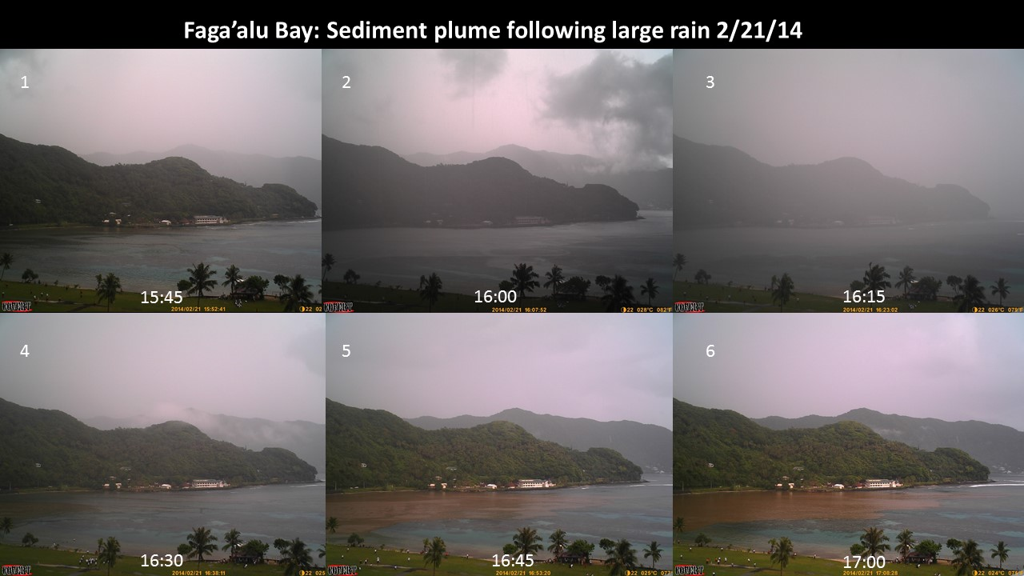

Figure 3. A sediment plume following a rainstorm in Faga'alu Bay 2/21/14. Waves breaking on the southern reef crest (to the bottom right) drive flow across the southern reef flat, deflecting the sediment plume northward (to the upper left), limiting sedimentation on the southern reef, and focusing sediment stress on the northern reef

**Sediment plume dynamics in Faga’alu**

Understanding the current speeds, flow patterns, and residence time of water over the reef flat is critical for understanding spatial and temporal patterns of sedimentation in the study site, Faga’alu Bay, American Samoa. Following large or intense storm events, suspended sediment is discharged into Faga’alu Bay and advected seaward over the reef by momentum, in a thin surface layer of high suspended sediment concentration (SSC)(>500mg/L)(Figure 3). This sediment-rich layer attenuates photosynthetically active radiation (PAR; (Piniak and Storlazzi, 2008)) and transports fine-grain sediment over the reef where it can settle out of the water column and onto coral organisms. Although the hypopycnal surface plume is able to move counter to prevailing currents (upcurrent) by sliding over denser seawater, as sediment particles settle they are entrained in the prevailing current and transported accordingly (Wolanski et al., 2003). As flow velocities increase, residence time of the plume over the reef flat decreases, limiting time for small particles to settle out of the water column and controlling the sedimentation rate, even for the same concentration and magnitude of different plumes. In general, field observations (Figure 3) suggest the sediment plume following rain events is deflected north, limiting sedimentation on the southern reef, and focusing sediment stress on the northern reef.

**Previous Research in American Samoa**

Little data on current circulation around Tutuila is available, and almost no data on circulation over the reef flat has been collected (CH2M HILL, 1984; Jacob et al., 2012; Wiles et al., 2012). Militello et al. (2003) modeled wave-induced setup on reef flats and developed stage-frequency relationships for large tropical storms and hurricanes in American Samoa. Thompson and Demirbilek (2002) characterized offshore wave climate from data collected near Western Samoa (1985-1990), and used numerical modeling to simulate wave propagation dynamics in Pago Pago Harbor. Vetter et al (2013)(unpublished) deployed wave/tide gauges in Faga’alu Bay on the southern forereef and reef flat, and an ADCP in the deep channel bisecting the reef crest, for one year (2012-2013). Vetter (2013) concluded flow dynamics in the bay were predominantly forced by waves breaking over the southern reef crest, and the wave influence increased linearly with tide height. Using an estimate of total lagoon volume, Vetter (2013) calculated flushing time varied from thirty-three hours during low wave height, to less than two hours during conditions when peak wave height was 1.6m, and mean current speed out of the main channel was 0.14 m/sec.

## Part Two Research Questions

The research questions for this paper are:

1. What is the residence time of ocean water over the northern and southern reef flats?
2. How are current speeds, flow patterns, and residence time affected by wave-, wind-, and tidal-forcing?

## Study Site

Faga’alu Bay, Tutuila, American Samoa (14.290738° S, 170.677836°W) is a V-shaped, reef-fringed embayment at the mouth of a small, steep-sided watershed (2.48 km2)(Figure 4). An anthropogenically altered, vertical-walled, 10-20m deep paleo-stream channel (‘ava in Samoan language) extends from the mouth of Faga’alu Stream eastward to Pago Pago Bay. This deep channel divides the reef into a larger Southern and a smaller Northern section. A microtidal regime varies semi-diurnally from approximately 0 to 1m, exposing parts of the shallow reef crest and reef flat at extreme low tides (<0m MSL).

Faga’alu Bay is situated on the western side of Pago Pago Bay, where it is protected by land from incoming swell from all directions except from the south to the east-south-east. The surrounding high topography blocks wet-season northerly winds (October-April), but the bay is exposed to dry-season southeasterly tradewinds and accompanying short-period wind waves (May-September). Faga’alu is only open to a narrow window of swell directions (S-SE) and swells approaching from a southerly angle refract to the west to break directly on the reef, reducing the energy of breaking waves. Offshore, significant wave height (Hs) from southerly and southeasterly directions are generally less than 2.5m and rarely exceed 3m. Wave periods (Tp) are generally about 9 s or less, rarely exceed 13 s but occasionally reach 25 s (Thompson and Demirbilek, 2002). Vetter (2013) recorded peak significant wave heights on the forereef in Faga’alu up to 1.7m, but wave heights greater than 1 m were rare (Figure 5). Given that the reef crest is nearly exposed at low tide, cross-reef transfer of water and wave energy is strongly dependent on the tidal stage and wave setup.

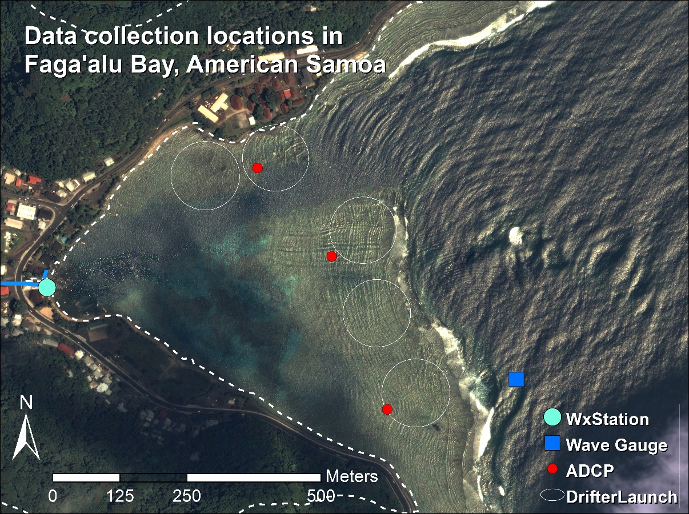

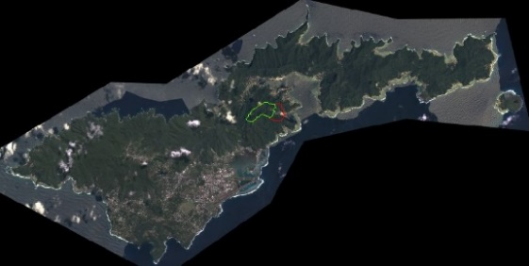

Figure 4. Data collection locations in Faga'alu Bay. Wind speed and direction was recorded at the weather station (WxStation), a Dobie wave gauge recorded wave height and period (Wave Gauge), three ADCP’s were deployed for one week to measure current speed and direction, and five GPS-logging drifters were deployed from the same five launch zones (DrifterLaunch) for thirty separate deployments (January to March, 2014).

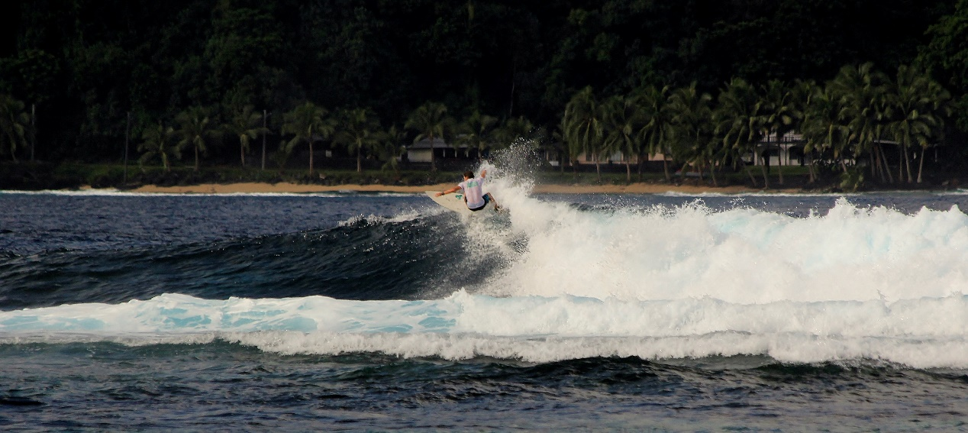

Figure 5. According to wave gage data, significant wave heights on the southern reef crest rarely exceed 2m but have been observed several times in the field coinciding with smooth seas and light winds in the wet season. Author included in photo for scale. Photo: Robert Koch, Am. Samoa Coastal Zone Management Program (ASCMP)

## Methods

While Vetter (2013) used wave/tide data and current speed in the main channel to calculate flushing time, those calculations are highly dependent on the estimation of total volume in the bay and are reliant on bathymetric data which is not well verified. Calculations of flushing time based on a few point measurements of current velocity also do not provide information on the spatial distribution of flow speeds or specific flow paths over the reef. Since it is known that residence time of water, in addition to water quality, is a strong control on coral health, it is desirable to characterize spatially distributed residence times in relation to wave, wind, and tide forcing.

### Eulerian vs. Lagrangian methods

To characterize the flow pattern over the reef flat in Faga’alu Bay, and to determine the relationship between wave- and wind-forcing and residence time of water over the reef flat, a combination of Eulerian and Lagrangian measurements was used. In fluid dynamics there are two ways to quantify the flow field: 1) the Lagrangian perspective observes an individual fluid parcel as it moves through space and time, 2) the Eulerian perspective focuses on specific locations, observing the fluid flowing past that location over time. Eulerian methods typically characterize water circulation on the reef using bottom-mounted instruments to record wave height and period, current speed and direction, and/or tidal elevation (Presto et al., 2006; Storlazzi et al., 2009). Collecting high spatial resolution data of hydrodynamic processes using strictly Eulerian methods is expensive and logistically difficult (Storlazzi et al., 2006b, 2004). While remote sensing is useful to map the temporal and spatial distribution of flood plume boundaries (Klemas, 2012; Warrick et al., 2007), the underlying current circulation is a strong control on sediment transport that may not be quantified by even high resolution remote sensing of plumes. Spatially distributed wave height, current speeds, and flow patterns can be predicted by hydrodynamic computer models (Hoeke et al., 2011), but models typically require accurate bathymetry, detailed forcing data, and significant modeling expertise (Hoeke, 2010; King et al., 2012; Wolanski et al., 2009). Lagrangian methods including the use of GPS-tracking drifters have been used to map flow patterns over reef flats to compare to Eulerian descriptions of flow speeds (Storlazzi et al., 2006a, 2004; Wyatt et al., 2012) or validate hydrodynamic computer models (Ouillon et al., 2010).

### Progress in using Lagrangian drifters

GPS-tracking drifters have been traditionally used to characterize oceanic circulation in the deep or coastal ocean (Davis, 1991; Warrick et al., 2007), but less expensiv, smaller GPS technology has recently made it possible to deploy many (n≥10) small drifters in nearshore environments to map flow patterns at finer spatiotemporal resolution (Austin and Atkinson, 2004; Johnson et al., 2003; MacMahan et al., 2010; Storlazzi et al., 2006a). Research on rip currents in beach surf zones have shown the ability to capture synoptic measurements of small-scale flow structures and patterns by deploying large numbers of GPS-logging drifters to collect high-density observations of flow speeds and directions (Johnson et al., 2003; MacMahan et al., 2010). Although deploying a fleet of GPS-logging drifters has yielded synoptic measurements of water movement in surf zones near linear, sandy beaches, it has not been attempted in a shallow reef environment.

### Combining Eulerian and Lagrangian measurements

Drifter studies in nearshore environments are typically limited in number of drifters, number of deployments, and/or the range of oceanic and meteorological conditions experienced during deployments, making it uncertain whether they describe the dominant patterns, or short-lived anomalies (Storlazzi et al., 2006a; Wyatt et al., 2010). While Lagrangian measurements provide spatially explicit data on the flow field, observations are limited temporally by their short duration times relative to Eulerian methods like in situ current meters. Storlazzi et al., (2006) compared Lagrangian drifter tracks with long-duration Eulerian current meter records to determine if short-term Lagrangian observations from drifters were representative of the dominant climatic patterns.

### Analysis of “end-member” forcing conditions

Current speed and direction data from three Acoustic Doppler Current Profilers (ADCP), providing Eulerian measurements, were deployed for one week and five GPS-logging drifters, providing Lagrangian measurements, were deployed approximately 30 times over two months, will be categorized according to end-member condition, with categories being “Wave-driven”, “Wind-driven”, and “Calm” (Hoeke et al., 2011; Presto et al., 2006). Under calm conditions, forcing is assumed to be attributed to tidal movement (Presto et al., 2006). If relationships between current speed and/or direction and wave-,wind-, or tidal-forcing are weak, data can further be subdivided by wind direction and tidal stage. Each GPS point recorded by the drifter is considered an independent observation, and drifter velocities and trajectories are calculated using a forward-difference scheme on the drifter locations (Davis, 1991; MacMahan et al., 2010). Given a high density of observations, drifter tracks can be binned as long as the bins are smaller than the scale of the flow structure to be observed (Davis, 1991). Drifter tracks will be binned by location (100 m x 100 m grid cells) and averaged over the time of deployment (MacMahan et al., 2010), yielding a grid of arrows pointing in the mean flow direction, sized by speed, and colored by number of observations, similar to Figure 6. Residence times will be calculated as a function of average flow speed through the 10m grid cell.

To determine if the short-term drifter deployments adequately describe long-term forcing conditions observed by the ADCP, two techniques are used to compare the drifter results with ADCP results: Empirical orthogonal functions (EOF) and progressive vectors of cumulative flow. EOFs determine the dominant modes of flow in the spatial domain, and the observed patterns at any given time period are described as a linear combination of the different modes (Emery and Thomson, 2004). EOFs and variance ellipses can also be calculated for binned drifter data and compared to calculations from ADCP data (MacMahan et al., 2010). Variance ellipses are commonly calculated from ADCP data to describe the relative magnitude of flow direction in the cross- and along-shore directions, and show the coherence of the flow: how strongly it flows in one direction, or if it is more variable (Hench et al., 2008; Hoeke et al., 2011; Storlazzi et al., 2006c). Progressive vectors from the ADCP measurements will also be calculated, and compared to drifter tracks (Storlazzi et al., 2006a).

To determine the relationship of residence time and wave-, wind-, and tidal forcing, regressions are calculated between forcing data and residence time (calculated from current speeds categorized by end-member conditions and binned over the north and south reefs) (Lowe et al., 2009).

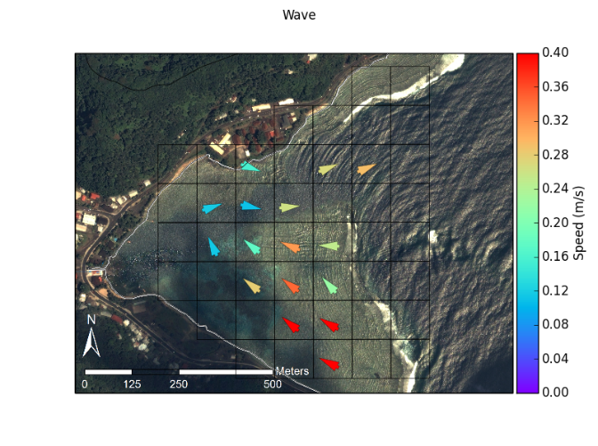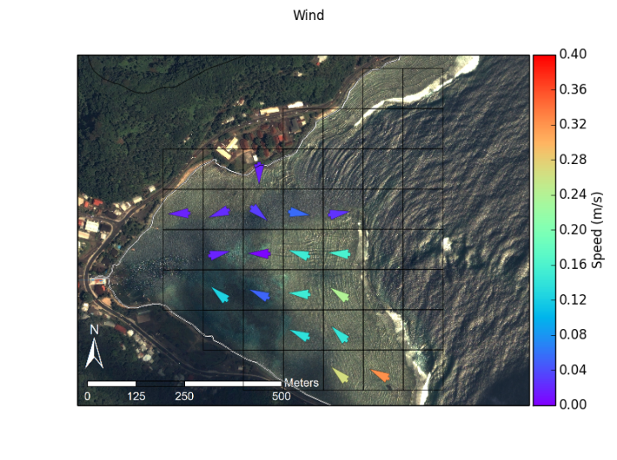

Figure 6. Drifter tracks during various “end-member” forcing conditions are binned by 100 m x 100 m grid cells and averaged.

## Field Data Collection

### Wave, Wind and Tide data

A NIWA Dobie-A wave/tide gauge (DOBIE) was deployed on the southern reef slope at 10m depth, and recorded in 512 second bursts at 2Hz at the top of every hour. The DOBIE malfunctioned and recorded no data coinciding with the ADCP deployment, but showed good comparison with NOAA WaveWatchIII (WW3) modeled data on swell height and direction. Swell height and direction output from WW3 will be used to characterize wave forcing in the analysis of the ADCP data and to define the endmembers for each measurement date (Hoeke et al., 2011).

Meteorological data during the study were obtained from a Davis VantagePro weather station installed near the stream mouth, approximately 5 m above sea level on a pole mounted to a building (WxStation, Figure 4). Wind speed, wind direction, barometric pressure, and precipitation were recorded at 15 min intervals. Meteorological and tide data were also recorded at a NOAA NDBC station (NSTP6), 1.8 km north of the study area. Wind speed, wind direction, barometric pressure, and water level were recorded at NSTP6 at 6 min intervals. For this study, wind conditions are sufficiently described qualitatively so the topographic effects on wind speed and direction recorded at the stations are considered inconsequential (Storlazzi et al., 2004).

### Eulerian and Lagrangian flow measurements

**Acoustic Doppler Current Profilers (ADCP)**

Three Nortek Aquadopp ADCP were supplied by the USGS Pacific Coastal and Marine Science Center in Santa Cruz, CA, and deployed on the reef flat in Faga’alu for one week: 15-23 February, 2014 (Figure 4; Figure 7). Flow speed and direction were recorded every 20 min at 1 Hz (not sure what the actual specs were, Curt programmed them). On the Northern reef the water level dropped below the minimum blanking distance of the ADCP at low tides, and flow is assumed to be nearly zero during these times given the relatively low water depth.

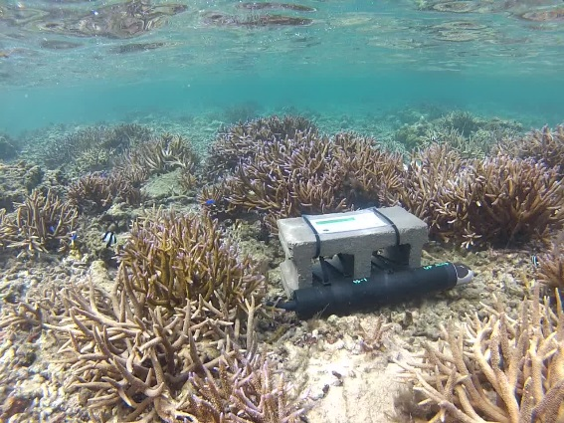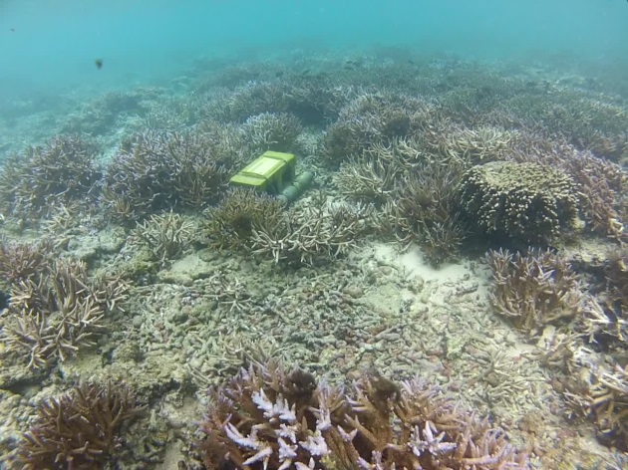

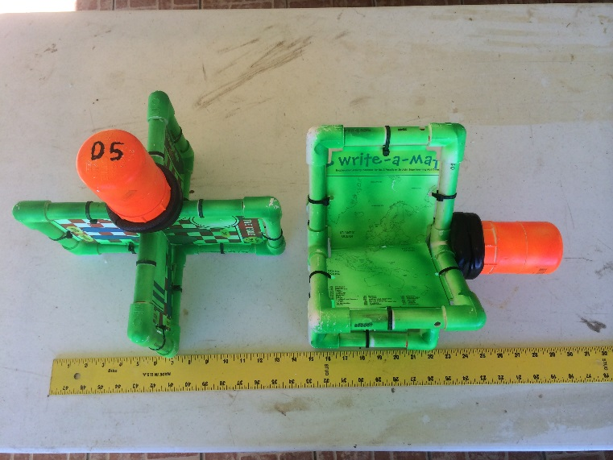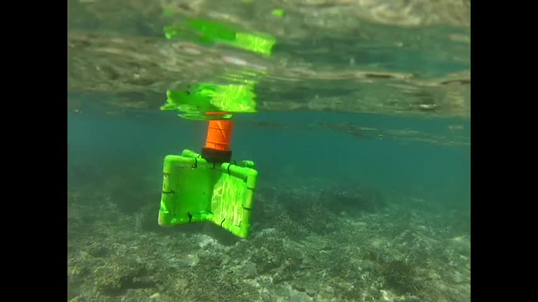

Figure 7. ADCP and drifter deployment.

**GPS-logging Drifters**

Drifter designs typically involve the use of a suspended drogue (Johnson et al., 2003; Ouillon et al., 2010) or a finned tube (MacMahan et al., 2009) to extend into and anchor the drifter in the water column. However, due to the shallow conditions experienced on reef flats a novel drifter design was needed. Drifters for shallow coral reef environments need to be shallow enough to avoid interaction with corals, deep enough to not be affected by the surface movements, extend high enough to be visible but not high enough to be affected by winds, and finally, rugged enough to sustain the impact of a breaking wave onto corals in the event it is entrained in the surf zone.

Faga’alu Bay is a relatively small area (0.25km2) so very high density drifter data could be collected with a small number of drifters (n=5) and field personnel (n=1). Five drifters were designed and constructed on-island, from PVC tubing and plastic sheeting, with a small waterproof housing for the GPS recorder (HOLUX M1000), and a float collar to maintain upright orientation (Figure 7). Deployments were conducted opportunistically to capture “end-member” conditions for all combinations of High-Low waves, High-Low wind (offshore and onshore), and High-Low tide. Multiple daily deployments were scheduled during one randomly selected week coinciding with ADCP deployment to facilitate direct comparisons of Eulerian and Lagrangian flow measurements under various forcing conditions. Thirty deployments were conducted, with twenty-two of those deployments coinciding with ADCP deployment.

## Expected Results/Outcomes

It is hypothesized that under low wave conditions, mean flow directions are more variable and mean flow speeds are lower. Under high wave conditions, mean flow patterns are more coherent in a single direction at a given point and mean flow speeds are greater. Flow patterns are less variable near the reef crest, and more variable on the reef flat, especially the northern reef flat. These hypotheses will be tested by variance ellipses calculated from spatially binned ADCP and drifter data, categorized by end-member forcing condition.

It is hypothesized that residence time of water over the northern reef will be longer than over the southern reef, despite the much smaller area of the northern reef, because wave exposure and resulting flow speeds are lower. This hypothesis will be tested by averaging residence time in each 10m x 10m bin over the north and south reefs under end-member conditions, and comparing their relationships with wave-, wind-, and tide-forcing.

The resulting empirical model of residence time over the northern and southern reefs will be used as a component of a top-down model of sedimentation on the reef developed in Paper Three. This study also tests a novel drifter design for use in shallow, coral reef environments, and provides a novel dataset of reef circulation from high spatial density drifter observations over a significant range of wave and wind-forcing conditions.

# Paper/Part Three – “Watershed and oceanic controls on seasonal and temporal patterns of sediment deposition in a fringing reef flat embayment”

## Introduction

The complex spatial and temporal interaction of terrigenous sediment inputs, sediment resuspension, and circulation can significantly alter the quantity, composition, and residence time of sediment in coral reefs, causing subsequent impacts on coral ecology (Storlazzi et al., 2009). Depending on the interacting hydrodynamic processes on the reef, increased terrigenous sediment supply to an embayment can increase sediment deposition on corals (Draut et al., 2009), or have no effect (Hoitink and Hoekstra, 2003). Coral stress and mortality resulting from sediment in the water column and sediment deposition is a complex process depending on hydrodynamics, sediment biogeochemistry, coral morphology, and coral physiology (Fabricius, 2005; Weber et al., 2012), making it difficult to quantify coral stress caused by sediment using biological monitoring strategies alone. This research focuses on understanding how the temporal and spatial distribution of sediment deposition on the reef is controlled by terrigenous sediment loading and oceanic conditions. Future research can relate the measured sediment deposition to coral health. Given the increase in sediment discharge to coastal waters caused by anthropogenic watershed disturbance on tropical islands, understanding how the interaction of flood-supplied terrigenous sediment and water circulation controls sediment deposition and residence time is essential for identifying and mitigating coral health impacts (Draut et al., 2009).

**Hydrodynamic controls on sediment deposition and residence time**

Hydrodynamic circulation driven by tides, wind, and waves can deflect plumes of suspended sediment away from coral, limiting stress from light attenuation due to turbidity (Hoitink and Hoekstra, 2003; Muzuka et al., 2010), and/or advecting suspended sediment over the coral and out to sea before it is deposited. Wave energy, either from remotely generated surface gravity waves or local wind-driven waves, is typically limited on shallow reef flats, but can cause high orbital velocities that shorten sediment residence time by resuspending and flushing previously deposited sediment or preventing sediment deposition (residence time = 0 min). Ogston et al. (2004) showed that while wave orbital velocities alone are generally unable to exceed the critical shear stresses necessary for sediment resuspension on fringing reef flats, in combination with the relatively strong current velocities, they can resuspend or prevent deposition of fine-grained sediment.

**Phasing of sediment input and hydrodynamic conditions**

Sediment loading from the main Faga’alu stream to Faga’alu bay is an important control on sedimentation rates on corals, but wave conditions decrease sediment deposition in two ways: 1) by flushing recently loaded sediment away from the corals before it can be deposited (in-phase with sediment discharge) and 2) resuspending and removing sediment that has been previously deposited (out-of-phase with sediment loading). Sediment loading out-of-phase with high swell conditions causes higher deposition rates and longer residence times than sediment loading in-phase with high swell conditions (Draut et al., 2009; Storlazzi et al., 2009).

In contrast to many small, mountainous watersheds in temperate coastal regions where fluvial discharge and wave energy commonly coincide (Warrick et al., 2004), discharge, deposition, and reworking of flood sediment is often decoupled on tropical islands, causing high deposition rates and residence times of terrestrial sediment (Draut et al., 2009; Storlazzi et al., 2009). Conversely, seasonal wind and wave patterns can be coupled with sediment discharge or resuspension to decrease sediment deposition and residence times (Hoitink and Hoekstra, 2003; Muzuka et al., 2010). Some studies correlate long term sediment accumulation with increased sediment supply, and by extension decreased coral health (Ryan et al., 2008), but there is strong evidence of hydrodynamics often preventing deposition or significantly controlling resuspension, and resuspension causing significant coral stress (Ogston et al., 2004).

**Measuring sediment accumulation on the reef**

Many researchers and environmental managers are interested in determining the location and severity of terrigenous sediment impacts on coral health, but developing an ecologically meaningful measure of sediment impact has proven difficult. Much research has focused on correlating coral health metrics like percent coral cover with sediment metrics like turbidity in the water column (Fabricius et al., 2012) or sediment accumulation on the reef or in traps (measured as mass per area per time)(Muzuka et al., 2010; Presto et al., 2006). Deploying tube traps is the most common method for measuring sediment accumulation in shallow coral reef environments, and collected sediment can be analyzed for composition to determine the terrigenous fraction (Gardner, 1980; Storlazzi et al., 2011; Takesue et al., 2009; White, 1990). Despite methodological differences in the collection and interpretation of these data (Storlazzi et al., 2011), it is difficult to determine if these are ecologically meaningful indicators of coral stress. Indeed some corals are well-adapted to turbid conditions (Perry et al., 2012), and deposited sediment can be removed actively by the coral itself, or passively by wave action, before it is lethal. The stress on the coral organism increases linearly with the deposition amount and the duration of exposure (Fabricius, 2005) but tube traps do not allow for sediment resuspension, making it impossible to evaluate the residence time of deposited sediment (Storlazzi et al., 2011). Field et al. (2012) proposed the use of “SedPods” where sediment accumulation is measured on a flat surface, allowing resuspension, but sediment tube traps are still widely used. Tube traps have been used to determine critical thresholds for coral stress, and although these thresholds vary by coral species and environmental setting, they give a relative measure of coral stress and can be compared among sites. While the complex interaction of sediment composition, hydrodynamics, and coral physiology are important, basic questions about location and controls on net terrigenous sedimentation rates are unknown at the study site in American Samoa, and are the focus of this research.

**Intellectual merit**

Many studies have measured sediment deposition on corals but few have developed an integrated understanding of the temporal interaction of flood-supplied sediment, water circulation patterns, and the resulting deposition on corals. The few studies that have integrated terrestrial and marine sediment dynamics were limited by a small number of flood events due to limited number of flood events in drier areas (Draut et al., 2009; Ogston et al., 2004; Storlazzi et al., 2009) or limited deployment times (Wolanski et al., 2005, 2003). Other studies have focused on only the tropical wet season when deposition is highest, and neglected investigating the important dynamics of potential sediment removal and flushing during the dry season (Muzuka et al., 2010; Victor et al., 2006).

The study will have important management applications, since detection of the efficacy of various efforts to mitigate sediment supply may be complicated by variable hydrodynamic conditions. This study will provide a framework for controlling for hydrodynamic effects that will allow quantification of the impacts of ongoing sediment mitigation efforts.

**Modeling monthly mean sedimentation**

Interpretation of any change in sediment accumulation rates following mitigation activities requires a conceptual and mathematical model of the dominant circulation conditions that control sedimentation on the reef. The modeling approach is similar to other efforts that have attempted to limit the complexity of the modeling approach, but still account for the impact of ocean conditions on sedimentation (Fabricius et al. 2012). The proposed model is a semi-empirical model using linear regressions and statistical methods to address the following research questions and test hypotheses about the influence of the dominant controls on sediment accumulation.

## Part Three Research Questions

The research questions for this paper are:

1. Temporal controls:
   1. How do flood-supplied terrigenous sediment and hydrodynamic conditions interact to control the gross and net rate of terrigenous sediment deposition at monthly time scales at different locations in a coral reef embayment?
   2. Is there a seasonal pattern of sediment deposition and removal, with sediment being deposited during the wet season when storms coincide with quiescent ocean conditions and removed during the dry season when storms coincide with active ocean conditions?
2. Spatial controls:

What controls the spatial distribution of sediment deposition, and can it be predicted by the flow direction and velocity of water over the reef?

**Conceptual model and hypothesized interactions of watershed and hydrodynamic processes**

This research proposes to model monthly sediment accumulation as a function of watershed inputs and hydrodynamic conditions to test hypotheses about their temporal and spatial distributions:

Temporal: In the study location (American Samoa), the wet season (Nov-Apr) is associated with large sediment loads from the watershed, light or absent trade winds and relatively low wave heights, while the dry season (April-Oct) has lower sediment loading, stronger trade winds and larger swell heights. Several studies have found weak or no correlation between sediment trap collection and rainfall parameters (Bothner et al., 2006; Victor et al., 2006) but it is well-known that sediment yield from small, mountainous watersheds can be poorly correlated with precipitation (Duvert et al., 2012). By correlating sediment trap collection with measured and modeled sediment yield from the watershed, this research hopes to assess the influence of variable sediment loading on sediment accumulation.

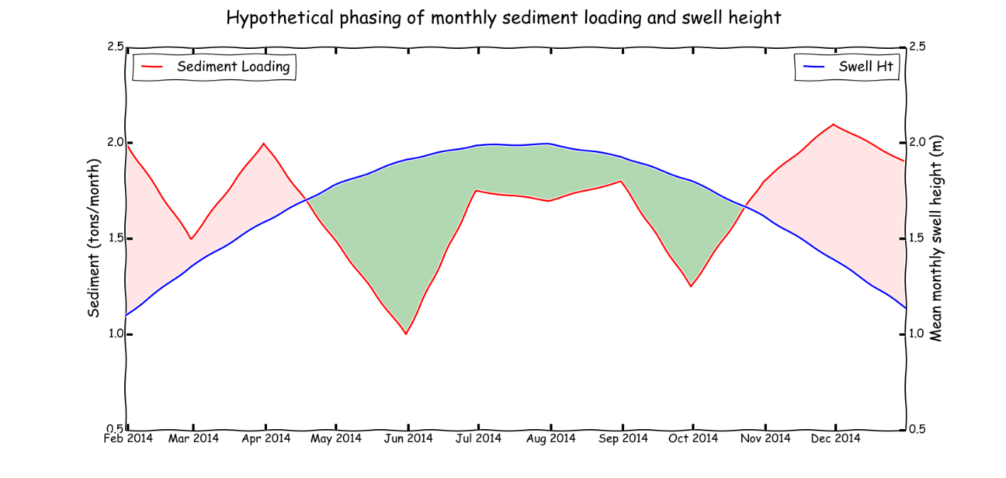

Figure 8. Hypothetical phasing of monthly sediment loading from the watershed and offshore swell height(Draut et al., 2009). Red shaded areas indicate a time of net terrigenous sediment deposition and green shaded areas indicate a time of net terrigenous sediment removal and suspension of marine-derived sediment.

Hypothesis 3.1: Terrigenous sediment deposition will be highest and marine-derived deposition lowest in the wet season, when rainfall events and watershed sediment inputs co-occur with light offshore winds and quiescent ocean conditions. In the dry season, stronger, onshore trade winds and higher average swell heights will decrease rates of terrigenous sediment deposition and shorten residence times, but will increase resuspension and deposition of marine-derived carbonate sediment compared to the wet season.

Hypothesis 3.2: The spatial distribution of sediment deposition will be controlled by the velocity of water circulation over the reef flat, and the distance from the point of sediment discharge (stream mouth). At the study site, current measurements and field observations suggest that there is a consistent hydrodynamic pattern, where ocean water is pumped over the southern reef crest by breaking waves, driving clockwise flow over the reef (Figure 9) that protects the southern reef from the sediment plume, and deflects the sediment plume over the northern reef.

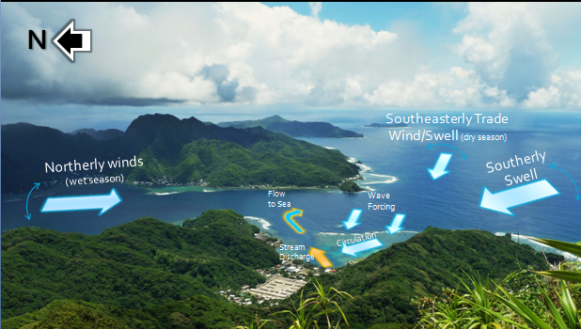

Figure 9. Conceptual model of wave/wind forcing of the dominant circulation pattern of sediment-poor ocean water deflecting sediment-rich stream discharge to the northern reef.

Hypothesis 3.3. The relative importance of watershed and hydrodynamic controls on the temporal variability will differ by location in the bay, with more hydrodynamic control at the ocean-ward parts of the reef that are not exposed to watershed inputs, and greater importance of watershed inputs in the parts of the reef where terrigenous sediment is hypothesized to accumulate.

These hypotheses will be tested with measurements of sediment loading from the watershed, of accumulation and composition of sediment in traps on the reef, and of oceanic and meteorological conditions. The impact of watershed inputs and water circulation will be assessed with statistically-based mathematical models.

## Pilot Study

In February and March, 2012, I measured total sediment accumulation at nine locations on Faga’alu reef using simple tube traps (STT), a ceramic tile (TILE), and an Astroturf mat (MAT). From April 2013 through June 2013 I measured total sediment accumulation using SedPods (Field et al., 2012). Sediment accumulation varied according to sediment trap type, location, and ocean conditions, and included both reef-derived carbonate and terrigenous sediment (Figure 2 and 3). No assessment of sediment composition was made, but sediment accumulation rate appeared to be controlled by sediment input from Faga’alu stream, and hydrodynamic circulation caused by high wave events.

The pilot study also demonstrated strong spatial variability in sediment deposition rates, with high rates near the stream mouth and on the northern reef, consistent with hypothesis 3.2. The pilot study data are insufficient to test the hypotheses due to a limited number of samples (n=5), no assessment of sediment composition, and insufficient data on hydrodynamic conditions. The methods developed in the pilot study have informed the development of the methods for the proposal.

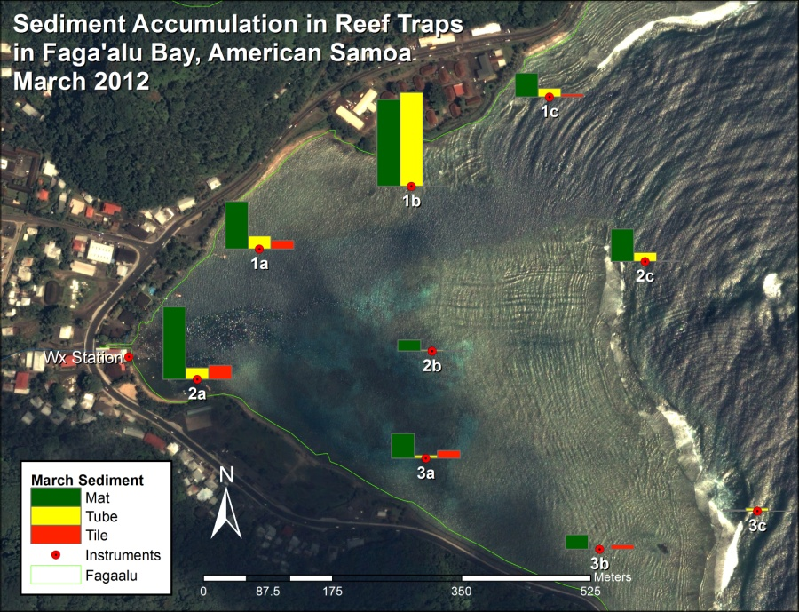

Figure 10 Gross sediment accumulation in tube, tile, and Astroturf sediment traps

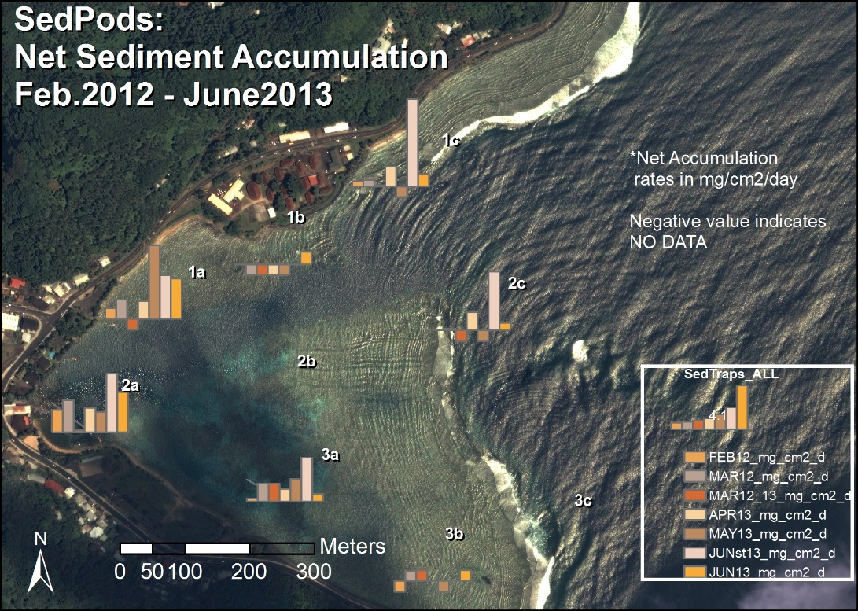

Figure 11 Net sedimentation on SedPods in Faga'alu Bay. Ceramic tiles were used in 2012 and were assumed to be comparable to SedPods.

## Methods

### Measuring sediment accumulation on the reef

Approaches to measuring sediment impacts on coral health have included monitoring suspended sediment concentration or turbidity in the water column (Wolanski et al., 2003) but suspended sediment in the water column can be caused by resuspension of nearby sediment due to shear stresses induced by wave- orbital velocities and/or mean currents, advection from another area, or any combination of these processes, and does not necessarily lead to sediment deposition. Geochemical methods (Takesue et al., 2009), sometimes in conjunction with coral skeleton analysis (Grove et al., 2010; Perry et al., 2012), have been used to infer sediment deposition over decadal and century time scales (Ryan et al., 2008) but can be complicated by subsequent sediment reworking and these time scales are ill-suited to the time scales of coral mortality and effective environmental management. Sediment traps are the most common method for measuring sediment accumulation in shallow coral reef environments, and collected sediment can be analyzed for composition to determine the terrigenous fraction (Storlazzi et al., 2011; Takesue et al., 2009; White, 1990).

Tube traps collect sediment over the deployment period, typically 1-90 days (Storlazzi et al., 2009; Victor et al., 2006; Wolanski et al., 2005), yielding an integrated sample and average collection rate in mass per area per time, but Field et al. (2012) argue the collection rate is a gross collection rate since particles cannot be removed as they would be on natural benthic surfaces. Since tube traps slow the water column and prevent resuspension, they can effectively trap sediment that would have been advected through the area without being deposited (Storlazzi et al., 2011). To more accurately quantify “net” sedimentation, Field et al. (2012) proposed the use of “SedPods” where a flat, circular, roughened concrete surface is deployed which allows for resuspension, similar to the surrounding benthic substrate. Deploying a tube trap in conjunction with a SedPod provides a comparison of gross and net sediment accumulation, and an assessment of the interaction of sediment loading and removal at time scales relevant to coral mortality and management.

SedPods (Field et al., 2012) and tube traps (Storlazzi et al., 2011) have been deployed at nine locations on the reef flat (water depth 1-2 m) and reef crest (10-15 m) in Faga’alu Bay, are being collected monthly to provide data on monthly sediment accumulation rates (mg/cm2/d) (Figure 11) from February 2014 through January 2015. Collection will be performed by Messina when in the field and by Department of Marine and Wildlife Resources when Messina is not on-island. See QAPP 2.2.11.1-2.2.11.4.

### Sediment composition and particle size

Sediment samples collected in tubes and SedPods are wet sieved to separate the sand and fine fractions for analysis and rinse salt from the sample. The samples are dried and weighed to determine bulk sediment accumulation before being shipped to SDSU to characterize the geochemical composition (percent terrigenous, carbonate and organic) using Loss on Ignition (LOI) method (Heiri et al., 2001; Santisteban et al., 2004). The LOI method uses a muffler furnace that can sustain 950 C for several hours to combust and remove organic, then carbonate material, leaving only terrigenous residue. All carbonate sediment is assumed to be reef derived, all non-carbonate is assumed to be terrigenous (Ryan et al., 2008). See QAPP 3.5. The particle size distribution and geochemical composition of sediment collected in traps may differ from sediment that accumulates on the reef, so sediments in the immediate area of the trap will also be sampled. See QAPP 2.2.11.5.

### Modeling temporal variation in sediment accumulation

Statistical models, including both simple linear regression models and more complex generalized additive mixed models (GAMMs) will be used to establish the relative controls of each measured variable on sediment accumulation rates, both the average for North and South reefs, and at each of the nine locations where accumulation will be measured.

A semi-empirical model of sediment accumulation (Si) at location *i* in the bay during month *t* as:

|  |  |  |
| --- | --- | --- |
|  | $$S_{i}(t)=f\left(S_{w}(t),R_{i}(t),{SB}_{i}\right)$$ | Equation 6 |

where *Sw(t)* is sediment loading from the watershed in month *t*, *Ri(t)* is mean water residence time over the reef flat at location *i*, either the mean of the month or mean during storm events, and *SBi*is substrate type (live coral, dead coral, coralline sand, mud) at location *i*, which is a proxy for sediment availability in the microenvironment around the sampling location.

**Sediment Loading**

Field observations suggest that sediment larger than fine sand settle before reaching the corals, so sediment accumulation and loading refers to particle sizes less than 16um (fine sand). Monthly sediment loading from the watershed (Sw) is calculated as the sum of suspended sediment yield from storm events (SSYi), using the model from paper 1:

|  |  |  |
| --- | --- | --- |
|  | $$S_{w}(t)= \sum_{i=1}^{n}{{SSY}_{i}}$$ | Equation 7 |
| where SMONTH is the sum of SSYEV for n events in the month. | | |
|  | $${SSY}_{i }^{*}= αQ_{max}^{β}$$ | Equation 8 |
| where the regression coefficients α and β are obtained by ordinary least squares regression on the logarithms of *SSYi* and *Qmax* (paper 1). Suspended sediment from each event during the month is summed: | | |

**Hydrodynamics**

Water residence time for each 100m x 100m grid cell containing a sediment trap/SedPod will be calculated from NOAA WaveWatch III swell model output and the model developed in Paper Two. Residence time is the amount of time a parcel of water remains in the grid cell, and is directly calculated from flow speed. Paper 2 proposes that residence time decreases with increased mean monthly swell height, and the relationship between swell height and flow speed in each grid cell will be determined in Paper Two, of the form:

|  |  |  |
| --- | --- | --- |
|  | $$R\left(t\right)=a{\overline{H_{s}}}^{-b}$$ | Equation 9 |
| where *R(t)* is the water residence time for month *t*, $\overline{H_{s}}$ is mean monthly swell height, and *a* and *b* are calibration coefficients. Depending on the modeling results from Paper Two, it may be necessary to calculate and average water residence time daily to determine mean monthly residence time. | | |

**Monthly mean versus daily models**

Monthly sediment accumulation may be a function of sediment loading and water circulation processes interacting on daily time scales, where hydrodynamic conditions only on the day of sediment discharge and not the mean monthly condition, are important. If monthly sediment loading and monthly mean residence time do not adequately predict sediment accumulation in the sediment traps, it might be necessary to investigate sediment loading and water residence times on daily scales, and further refine the statistical analysis and equations. In that instance, daily sediment loading and daily mean residence time will be used to assess daily deposition, which can be compared to the monthly sediment accumulation measurements.

**Monthly and Seasonal patterns of sediment deposition and removal**

Two time scales of analysis will be pursued: monthly and seasonal (dry and wet season). Monthly measurements of sediment loading, hydrodynamic conditions, and the subsequent sediment accumulation are used to assess the importance of controls on net sedimentation. A monthly time interval was chosen to correspond with other studies found in the literature (Muzuka et al., 2010; Victor et al., 2006), to sample enough storm events to collect enough sediment for analysis, and for logistical reasons due to the high spatial coverage of sites and limited field personnel and resources.

An assessment of differences between dry and wet season sediment dynamics is useful to determine if there are seasonal patterns or modes that may be relevant to long term sediment accumulation (Ryan et al., 2008) or coral conservation and restoration (Muzuka et al., 2010). Previous studies have focused on wet season sediment deposition (Muzuka et al., 2010; Victor et al., 2006) and may overestimate long term sediment accumulation. It is hypothesized (hypotheses 3.1) that net deposition predominantly characterizes the wet season, and a net sediment removal, or limited deposition, predominantly characterizes in the dry season. The sediment accumulation data will be grouped by season and averaged to determine if there are seasonal patterns of net deposition/removal.

### Modeling spatial variation of sediment accumulation (kernel values)

An important consideration for coral conservation is determining the spatial distribution of sediment impacts from terrigenous sediment loading. Current conservation models typically use the distance from the river mouth or other point source to assess pollution risk to coral reefs (Klein et al., 2012), but wave and wind-driven flow over the reef can deflect suspended sediment away from corals (Hoitink and Hoekstra, 2003) or focus impacts on small areas of reef (Presto et al., 2006). To explain the spatial variation of sediment accumulation between sediment traps, and determine if flow direction or distance from the stream is more important, a kernel-based approach will be used. The “kernel” is a method of analyzing spatial distribution by normalizing all measurements by the maximum observed measurement, which are then modeled as a function of water flow direction (towards/away the stream mouth) and distance from the stream mouth:

|  |  |  |
| --- | --- | --- |
|  | $$\frac{{\overline{SedAcc}}_{i}}{{SedAcc}_{MAX}}=f(V_{θi},d_{i})$$ | Equation 10 |
| Where $\overline{SedAcc}$ is the mean monthly sediment accumulation measured at trap *i*, SedAccMax is the highest observed sediment accumulation of all sediment traps, *Vϴi* is velocity in the direction away from the stream mouth at location *i,* and *di* is distance from the stream mouth at location i. | | |

## Expected Results/Outcomes

A serious problem faced by attempts by environmental managers and researchers to assess stress on reefs is the fact that there are few, if any, reefs with adequate baseline data (Risk, 2014). The proposed work will characterize and quantify the amount, composition, and particle sizes of sediment contributing to coral reef degradation in Faga’alu, informing mitigation strategies to reduce terrestrial sediment loading to the priority coral reef. The work will establish a baseline to measure the performance of future mitigation projects by developing a model that relates sediment loading from the watershed to sedimentation rates on the reef under varying oceanographic conditions.

The main outputs of the work will consist of a statistical model of sedimentation in Faga'alu Bay that quantifies the relative importance of watershed inputs and ocean circulation on sediment dynamics, and tests the above hypotheses.